Startup:
To invoke chart on any script kindly press Shift+P

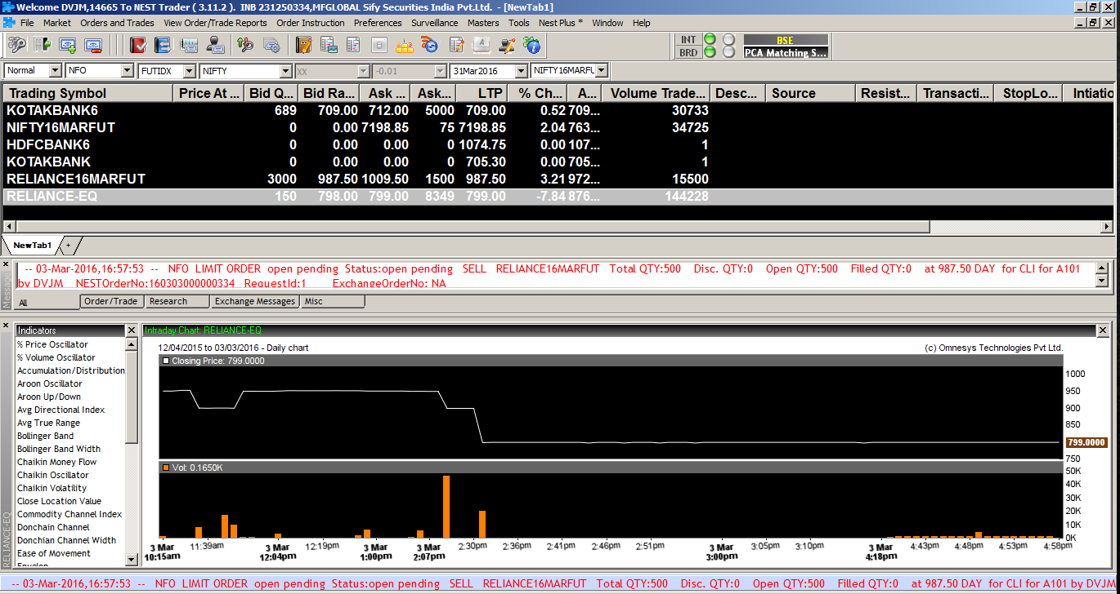

The chart UI contains by default Candle Bar chart with the below end having volume bars and the left side with studies that can be implemented in the chart.

Nest Chart layout:
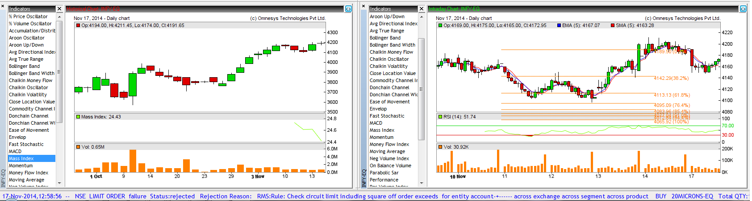

Features in Chart charts: Given below is the screenshot of the features of Nest Chart that you can invoke by right click anywhere on the chart area.
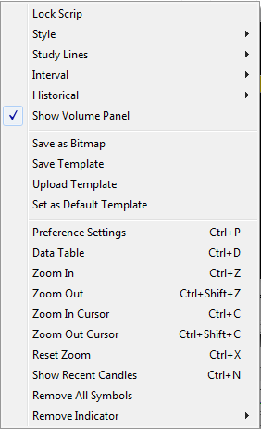

Multiple Charts:
Use the first option Lock scrip to invoke multiple charts. User can invoke 5 different charts.

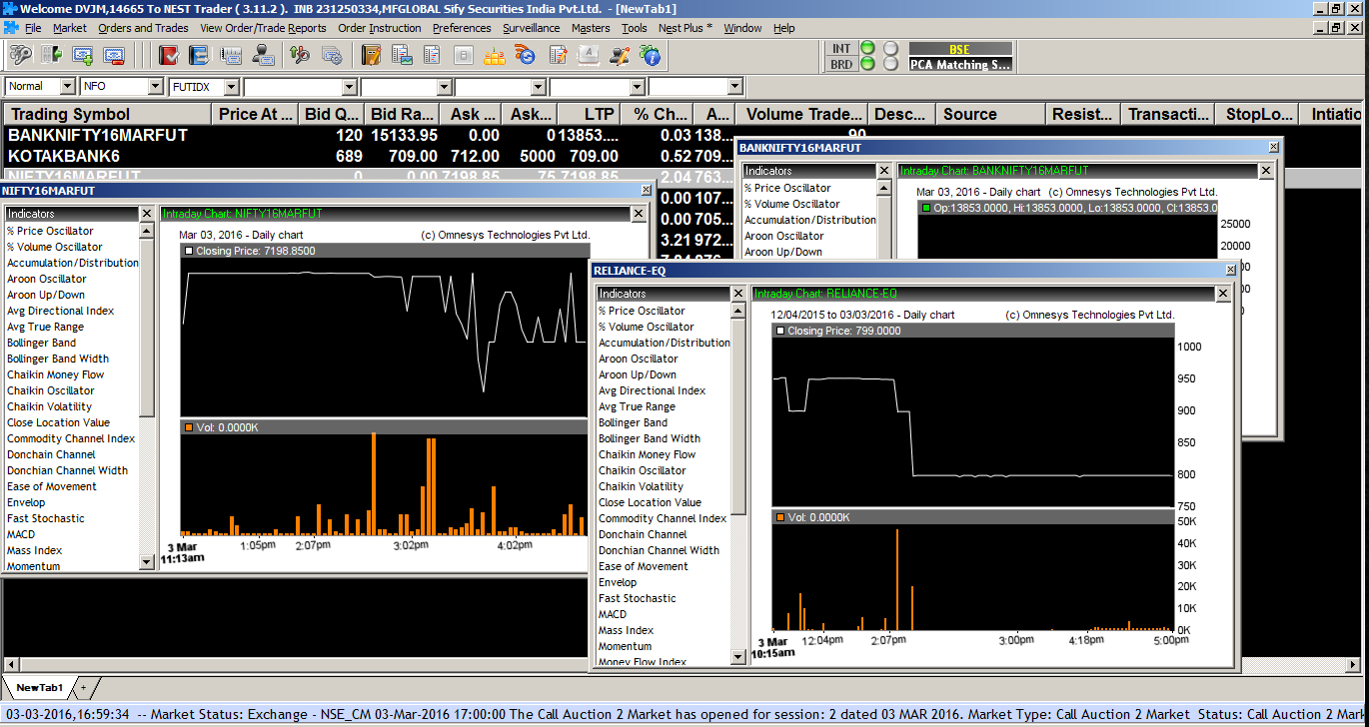

Style:

Chart styles define how the chart must be plotted for any given data.
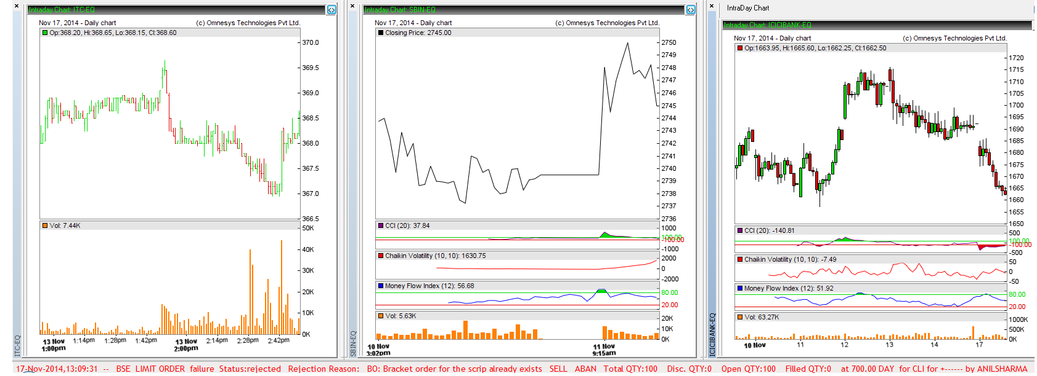

Study Lines:

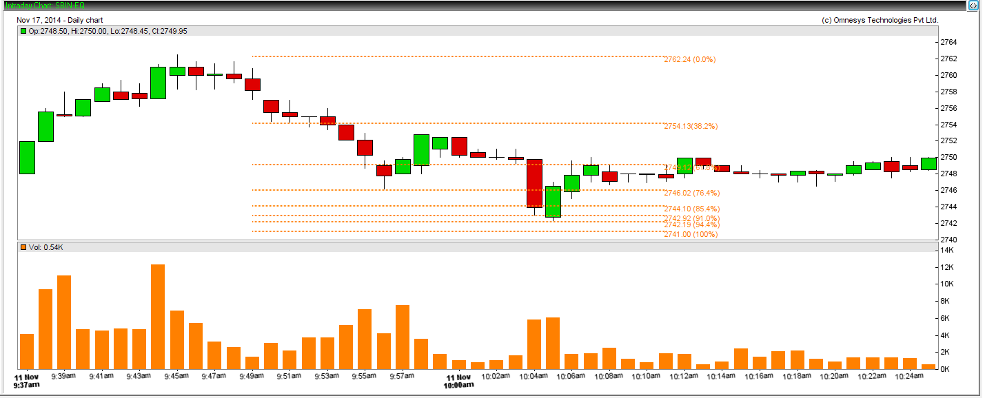
Study lines are useful for chart analysis. Different study lines such as Ellipse, rectangle, trend line, speed lines, fibonacci retracements etc.

Interval:

Chart directory offers configurable intervals on intraday chart. One can view in 1min, 5mins, 30 mins and 60 mins interval
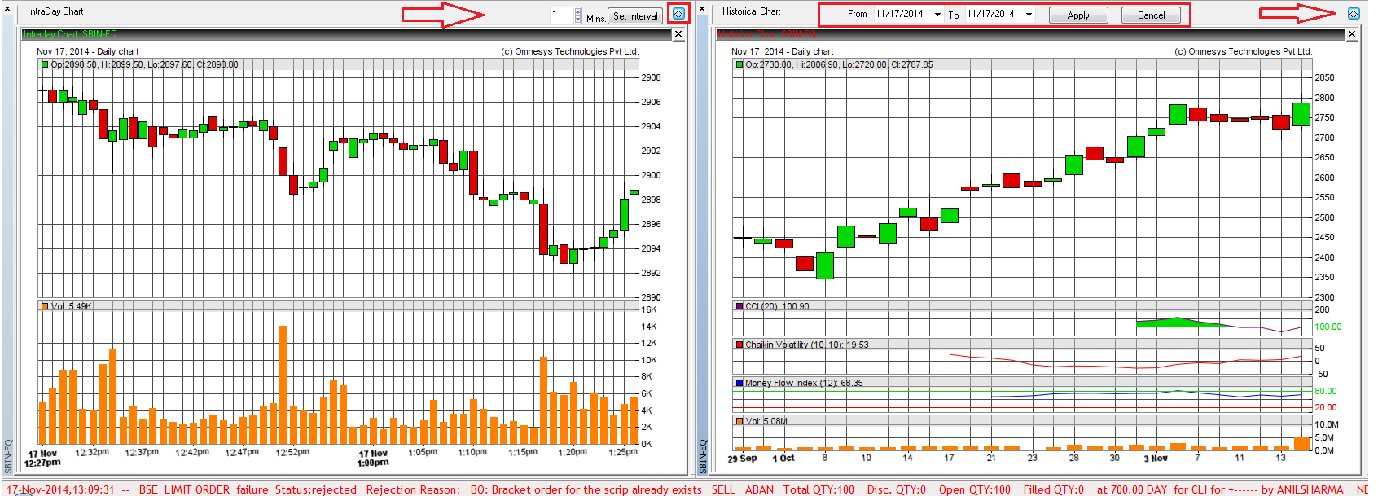
Volume panel:
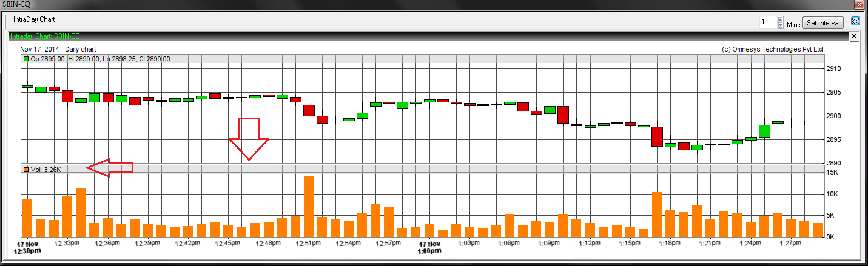

Save as Bitmap: This is to capture a chart image.

Save Template, upload template and set as default template: This helps in having a set of indicators for the charts by uploading saved templates.

Preference settings:

It helps to change the chart appearance based on user requirement.

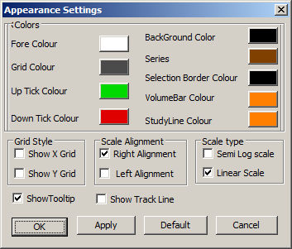

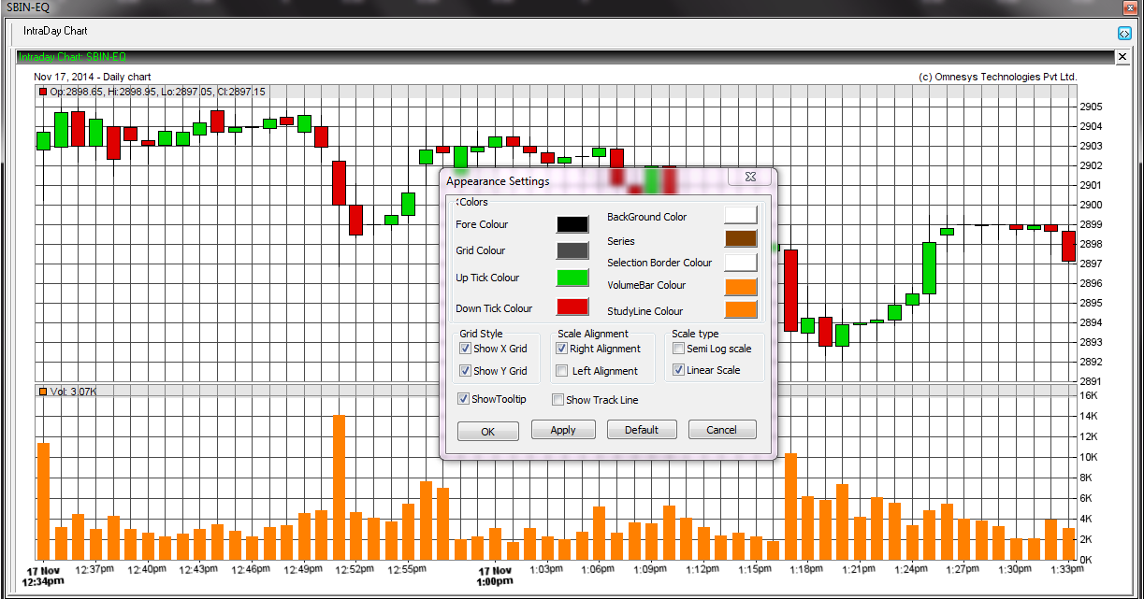

EOD

